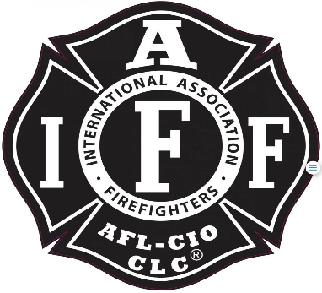

Rogue Valley Professional Fire Fighters
IAFF Local 1817

Minutes - Union Meeting
November 14, 2023 at 6:00 PM, Via Zoom video-conference
ATTENDANCE
E-Board Members Present: Brian Anders, Brian Simonsen, Eric Merrill, Travis Linville
Members Present: Allyson Jeffs, Rob English, Trevor Peterson, Evan C, Andy C, Clayton M, Michelle F, Josh B, Joey F, Connor T, Jason A, Jarred H, Collin L, Ben K, Cole H, Jarred N, Tony V, Greg S, Ethan M.
The meeting was called to order by President Anders at 6:01 p.m.
Approval of Minutes:
No objections or additions. Jason Allen makes a motion to approve minutes from September meeting. Collin Lee seconds. Minutes were approved.
Meeting Topics:
Eric Merril: Budget: Provided an update and explanation on all line items in the budget. Current Balances are posted on the union website. Various questions were asked and answered. An increase to expense was for Union dues to O.S.F.F.C and IAFF National, our rosters had not been updated since 2015.
Brian Anders:
Training Lieutenant: MOA has been approved and was sent out to all members. Admin will be posting position soon.
Negotiations: Negotiations will be kicking off in February of 2024. Declaration to the District will take place in January 2024. Working on getting comparable salaries from around the other agencies. Will C had removed himself from the team as he is moving into office. Levi S was the next alternate.

Good of the Order:
Travis: Will be sending out 2024 calendars. Looking for anyone interested in designing new logo for swag.

Adjournment:
Motion to adjourn by Clayton M, 2nd by Brian S. No objections. Meeting adjourns at 1850.

Approved by, Submitted by,

________________________ _______________________
President – Brian Anders Secretary - Travis Linville

