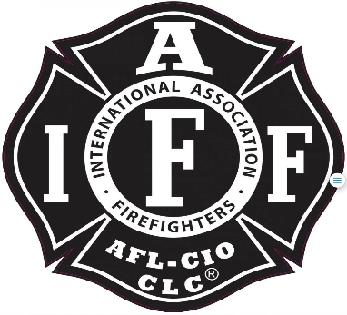

Rogue Valley Professional Fire Fighters
IAFF Local 1817

Minutes - Union Meeting
March 12th, 2024, 6:00 PM, Via Zoom videoconference
ATTENDANCE
E-Board Members Present: Brian Anders, Brian Simonsen, Eric Merrill, Travis Linville
Members Present: Collin L, Ben K, Jason A, Andrew C, Clayton M, Trevor P, Evan C, Michelle F, Karli B, Rose E, Cole H, Allyson J, TJ L, Jared H, Patrick B, Garrett B, Joey F, Rob E, Scott D, Jacob P, Alex C, Tony V, Greg S.
The meeting was called to order by President Anders at 6:05 p.m.
Approval of Last Meeting Minutes:
Ben K makes a motion to adopt January meeting minutes, Eric M seconds. No objections and no abstains.
Meeting Topics:
Eric M- Treasurer Report: Income paid out for D4 negotiators and 1099’s. Taxes are being prepared currently. See budget report on Union Website for each account and amounts.
Brian Anders: New position as a fuel reduction crew supervisor. The supervisor will be in a year-round position and will be represented.
Anders hands the chair of the meeting over to VP Simonsen.
Action Item: Motion to amend by-laws to include Crew Supervisor and to begin talks regarding position. Andrew C makes a motion. TJ L seconds. Anders provided info regarding the timeline for the next two months and the info that will be released to the Members as it becomes available for everyone to make informed votes during the May meeting.
Ben K: Asked if the position is full time/ on trial bases etc. The Crew Supervisor will be guiding the Risk Reduction Crews in the Summer and then transition and work with Risk Reduction Captain during Winter months.
Rob English: Asked is there an official rank? Anders stated not on the suppression side and the position will live under JP in reduction. English continued with the fact that the new position will not have a rank and will be supervising people.
Anders will reach out to TLG regarding rank/ department structure.
Jason A: Asked does the CommCare Supervisor have a rank? Commcare will be the top of CommCare.
Allyson J: Asked if this position is looking to be filled in house or outhouse. Anders provided it will be filled from the outside most likely.
Ben K: Asked why are we creating a new position as opposed to hiring a contractor to perform the work? Anders provided info regarding lack of local resources able or willing to do the work. The supervisor will not be performing any suppression activity and will be performing after-fire activities (gridding, smoke checks, etc.). The MOU and updated job description will provide more information.
Clayton M: Wanted clarification regarding which position will be represented and which won’t.
Brian: Makes a motion to table this for the May meeting, Allyson J. seconds. No objections, No abstains.

Travis: Keep mailing addresses updated to the Union. This is vital for receiving notifications for notices on votes/ amendments.
Brian: Discussed all positions are up for nominations this May. Reach out to any E-Board member for info regarding the positions.
Eric M: Negotiation Meeting Update: Living documents are up on the website and will auto update as negotiations continue. Review the document for up-to-date accurate information.
Good of the Order:
Karli B: Proposes looking into RVPFF Fund it will be a non-profit. 501.3c Patients living conditions, collect donations for various patron needs, could allow citizens to donate and have a tax deduction. The cost to start is approx. $600.
Jason A: Asked about who would help over see the fund, potentially our Tax preparer.
Brian A: Provided that this is in early discovery phase as gathering information will be on-going.
Brian A: Pat Haynes is making a good recovery after his accident.

Adjournment:
Brian: Looks for a motion to adjourn. Ben K makes a motion to adjourn, Evan C seconds. No opposition. No abstains.

Meeting Adjourned at 1900.

Approved by, Submitted by,

________________________ _______________________
President – Brian Anders Secretary - Travis Linville

