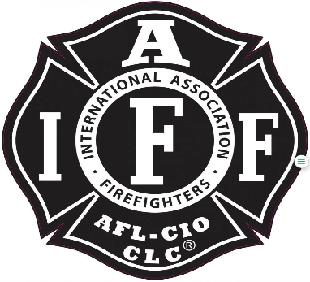

Rogue Valley Professional Fire Fighters
IAFF Local 1817

Minutes - Union Meeting
November 12, 2024, at 6:00 PM, Via Zoom videoconference
ATTENDANCE
E-Board Members Present: Brian Anders, Brian Simonsen, Eric Merrill, Travis Linville
Members Present: Javier L, Chad L, Neil C, Jared N, Rob E, Cole H, Kenny H, Ethan M, Corbin L, Allyson J, Andrew C, Jason A, Don M, Collin L, Caleb E, Jared H, Clayton M, Junior O, Levi S
The meeting was called to order by President Anders at 6:13 p.m.
Approval of Minutes:
Andy C makes a motion to adopt the September minutes. Cole H seconds the motion. None opposed.
Action Items:
40.1 Budget Update: Eric provided a breakdown of the proposed 2025 L1817 Budget. He provided a detailed breakdown of 2025 and the previous years. The budget will be posted to the union website to allow for members to view it. Voting will start at the conclusion of this November meeting and run until midnight Friday November 22nd.
Discussion Items:
Budget Update: Budget is posted on the union website. Checking, $135,220.26/ Savings $3,700/ Investments $57,170.84.
E-Board Updates: Brian provided that the IGA with FD5 has been signed (see Hussey’s email). It doesn’t take effect until January. The commcare coordinator will be going live and the District will be looking to advertise soon.

Money on the Engines:
This has been a long time in the making. The E-Board has been working through Tax law and what the Local needs to do with cash on the engines. This has taken longer than expected, thank you Mark for the leg work. We are working through the final details (securing the cash and getting cash out of the accounts.) Jared asked about the non-profit that Karli was working on. Anders stated that if anyone outside the E-Board would like to take that on, by all means. There would need to be a lead and the creation of a new board. It is currently sitting idle even though Karli did a lot of the leg work.
Retirement Watches:
The idea was to have the option to hand something down from retirement to your kids/ family. Levi asked around to get the back story on what the Union does for a retiree. If they want money we refund a year of union dues; roughly $1,400. Parties can be simple BYOB and food (does not need to be funded by the Local). This would be an item that memorializes the years of service. Would the District be willing to share the cost. Brian added that this may be a good jumping off point to standardize the way we honor retirees. Levi has been asked to send out the watch idea to all members. Any questions send to any E-Board member.
Coffee Talk:
Numbers have changed. We now have a second admin building and more members will be drinking the coffee. Jared shared the numbers for various coffee vendors. Local and Muertos Coffee. This will be added to the January agenda under action items. Currently the Local does not provide money for coffee.
Weingarten Rights/ Garrity Rules/ and Loudermill Rights:
Travis has provided an overview of these rights. The biggest takeaway is to seek union representation if you are asked to partake in a meeting (if the meeting may lead to discipline). Brian added some more information on documentation that is needed. Levi stated it was a good reminder. Thank you to the member who requested a reading of these rules.
Unwritten Rules:
This would be a living document that would provide some rules of respect to one another. Send all items you would like added to Mark.

Old Business:
None
Good of the Order:
The Oregon State FF Council will be having a State conference with education for Union leadership. This will be good for any member looking to move forward in the E-Board.
New email addresses for E-Board Members. This will allow for information to flow more smoothly during E-Board transitions.
E22 asked if the Union was going to get an office room from the admin building.

Adjournment:
Clayton M makes a motion to adjourn, Andy C seconds the motion to adjourn. None objections recorded.

Approved by, Submitted by,

________________________ _______________________
President – Brian Anders Secretary - Travis Linville

